# 3: CORROSION AND ITS CONTROL

Introduction, Importance of corrosion study, Corrosion classification, Electro chemical theory with special reference to rusting of iron. Galvanic series: need, characteristics, advantage. Factors affecting corrosion: Primary and Secondary factors. Brief account of galvanic corrosion, pitting corrosion, intergranular corrosion and stress corrosion. Corrosion control by material selection and proper design. Corrosion control by use of inhibitors, Cathodic protection of metals, Anodic protection and metal coating, Corrosion control by organic (paint) and inorganic (phosphate) coatings.

**Learning Objectives:**

1. Unfold the practical aspects of metal corrosion with real life examples.
2. Be able to describe the mechanism of corrosion by electrochemical theory
3. Describe different forms of corrosion- galvanic, pitting, inter-granular and stress corrosion
4. Demonstrate an understanding of the importance of the factors affecting corrosion
5. Know about the different established and modern techniques to control corrosion such as anodic/cathodic protection methods, organic /inorganic coatings
6. Distinguish between dry/wet corrosion, galvanizing/ tinning, electrochemical series/ galvanic series and organic/inorganic coating

# 1. INTRODUCTION

Various types of metals are used in residential and commercial structures, in bridges, in automobiles, passenger trains, railroad cars, ships, in pipelines and storage tanks. In addition, metals are also used in various electronic applications such as printed circuit, computer discs, connectors and switches. Metals also find use as coins of daily commerce, in jewellery, in historical landmarks and in objects of arts. Some metals find application in human body as replacements, as stents, as surgical plates, screws and wires. Whatever be their end use all common metals tend to react with their environments to different extents and at different rates. Thus, Corrosion is a natural phenomenon and is the destructive attack of a metal by its environment so as to cause a deterioration of the properties of the metal.

Corrosion can be defined as spontaneous destruction or deterioration of a metal or alloys by the surrounding environment because of chemical or electrochemical interaction. Free metals, as such are unstable and whenever favourable situation arises they combine with other elements like oxygen and form the compounds of minimum energy and maximum stability. Hence corrosion can be viewed as the reverse process of extractive metallurgy. This phenomenon is schematically represented in Figure 1

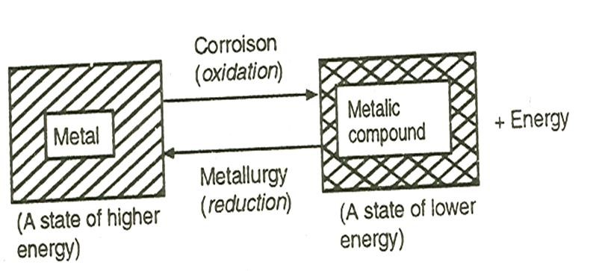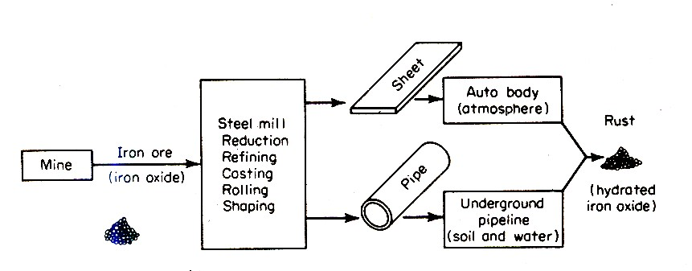

**Figure 1:** **Corrosion as reversal of metallurgy**

4Fe(s) + 3O2 (g) →2Fe2O3(s) (rust) , Fe2O3 (s) + 3 CO →2Fe(s) + 3 CO2 (g)

Three most common examples of corrosion include rusting of iron objects forming reddish brown scale, tarnishing of silver in contact with traces of H2S or SO2 in the atmosphere or eggs rich in sulfur compounds and formation of green scales on copper vessels. The process and the products formed in these reactions are described in the following equations.

*Rusting of iron* 4Fe(s) + 3O2(g) → 2Fe2O3.H2O(s)

*Tarnishing of silver* 4Ag(s) +2 H2S(g) + O2(g)→ 2Ag2S(s) + 2H2O(l)

*Scales on copper* 2Cu(s) + H2O(l) + O2(g) + CO2(g)→Cu2(OH)2CO3(s)

## 1.1 Importance of corrosion study

The study of corrosion is an interdisciplinary area embracing chemistry, material science and mechanics. Four reasons to study corrosion as science and engineering subjects are:

**Human life and safety**: Loss of life results due to combined effects of stress and corrosion when structures collapse. Safety issue can be due to the build up of certain toxic product due to corrosion, sudden failure of equipment may cause fire or explosion.

**Cost of corrosion**: The annual losses due to corrosion are approximately 3-4% of GDP in many advanced countries and it is even more in developing countries.

**Conservation of materials**: Corrosion destroys metals by converting them into corrosion products. Thus corrosion affects the supply of the earth’s material resources.

**Academic interest:** The study of corrosion is in itself a challenging and interesting as corrosion science is an interdisciplinary area involving chemistry, materials science and mechanics. A blend of these must be included to understand the various forms of corrosion.

## 1.2 Economic considerations of corrosion

Corrosion consumes 3-5% of the Gross National Product of that particular nation. Corrosion costs could be divided into direct and indirect costs. The direct losses include inability to use otherwise desirable materials, overdesign to allow for corrosion, the cost of repair or replacement of corroded component, cost of anticorrosive painting or other protection methods. Indirect losses may be either economic or social. These may include shutdown of power plants and manufacturing plants, loss of product due to leakage, contamination of product, loss of production and safety issues. In addition to direct costs in dollars, corrosion is serious problem because it definitely contributes to the depletion of our natural resources. The rapid industrialization of many countries indicates that the competition for and the price of metal resources will increase.

## 1.3 Corrosion science versus corrosion engineering

Corrosion science is directed towards gaining basic scientific knowledge to understand corrosion mechanisms. Corrosion engineering involves the use of accumulated scientific knowledge to corrosion protection and prevention. Corrosion science and corrosion engineering complement and reinforce each other. Understanding of corrosion mechanisms can lead to possible new corrosion-resistant alloys, better surface treatments, and improved corrosion control measures. Understanding of corrosion engineering aspects will trigger the interest in doing research in finding out actual mechanisms involved in the process..

## 1.4 Consequences of corrosion

* Maintenance and operating costs: One fourth of the iron produced is used to replace bridges, buildings and other structures that have been destroyed by corrosion. The corrosion causes damage to chemical process plants and other equipment.
* Plant shutdowns, loss of production while the plant is inoperable during repairs/replacement work.
* Contamination and loss of valuable products- Leaking containers, tanks, pipelines results in significant losses in product, which have a high cost. Soluble corrosion products can spoil and contaminate chemical preparations.
* Effects on safety- The contaminated products when dumped cause environmental pollution problems.
* Loss in aesthetic value- Reduced value of goods due to degraded appearance
* Loss of technically important surface properties such as friction, surface reflectivity, heat transfer and electrical conductivity.
* Loss of efficiency- the corrosion products decreases the heat transfer rate in heat exchangers

# 2. 0 CORROSION CLASSIFICATION

Two different types of corrosion are

* *Dry or Chemical Corrosion*  and *Wet or Electrochemical Corrosion*

## 2.1 Dry or Chemical corrosion

This type of corrosion occurs by direct chemical reactions between the environment and the metals and alloys. Presence of an electrolyte/conducting medium is not at all essential for this type of corrosion to occur. Therefore this kind of corrosion is also known as dry corrosion. Depending upon the nature of the corrosive environment, dry corrosion may be further classified into three types.

***(i) Oxidation corrosion***: It occurs when metals are attacked by dry oxygen (absence of moisture) at extreme conditions like low or high temperature. The direct oxidation of metals takes place according to the following reaction scheme:

2M → 2Mn+  + ne−

nO2 + 2ne− → 2nO2−

2M + nO2 → 2Mn+ 2nO2−

In general: Metal + Oxygen→ Metal oxide (corrosion product)

When the oxidation starts, a thin layer of oxide is formed on the metal surface. Nature of this film decides the further corrosion process. If a stable film is formed, it behaves as protective coating and, thereby it shields the metal surface from corrosive environment. Consequently, further oxidation of metal is prevented. eg: Al, Sn, Pb, Cu and Pt. Unstable metal film decomposes back into the metal and oxygen. Hence oxidation corrosion is not possible in such cases: e.g. Ag, Au, and Pt. In some cases, oxide film layer volatilizes as soon as it is formed, thereby accelerating the corrosion. e.g: MoO3.

***(ii) Corrosion by other gases*** : It is due to some gases SO2, Cl2, CO2, and H2S, depends mainly on the chemical affinity between the metal and the gas involved. For example, dry Cl2 attacks silver metal and forms AgCl as a thin protective and non-porous layer on the metal. As a result of this protective layer on the metal surface, the intensity of corrosion decreases.

***(iii) Liquid metal corrosion*** : It occurs when a molten liquid is continuously passed on a solid metal surface or on alloy. This behaviour may be either due to the dissolution of the molten liquid or due to penetration of the molten liquid into the metal phase.

## 2.2 Wet or Electrochemical corrosion

Wet corrosion occurs due to the existence of separate anodic and catholic areas, between which current flows through the conducting solution. It involves flow of electron current between the anodic and cathodic areas through electronic conductor. This type of corrosion can be observed when

1. A metal is in contact with an acid solution and
2. Dissimilar metals are dipped partially in a corrosive environment.

### 2.2.1 Electrochemical theory of corrosion

Corrosion usually occurs not by direct chemical reaction of a metal with its environment but rather through the operation of coupled electrochemical half-cell reaction. According to electrochemical theory of corrosion, when a metal is exposed to corrosive environment, the process of corrosion sets in by the formation of a large number of ‘anodic’ and the ‘cathodic’ areas on the metal surface (microgalvanic cells). A driving force is necessary for electrons to flow between the anodic areas to the cathodic areas. This driving force is the difference in potential between anodic and cathodic areas. This difference exists because oxidation and reduction reaction has associated with it a potential determined by the tendency of specific elements for the reaction to take place spontaneously. This electrode potential is a measure of the tendency of a metal to undergo oxidation or reduction reactions. Corrosion always occurs at the ‘anodic area’ of the metal due to oxidation process and thus electrons are liberated.

**Anodic reaction**:

M → Mn+ + ne−

Fe → Fe2+ + 2e−

Al → Al 3+ + 3e−

**Cathodic reactions**

The electrons set free at the anodic area flow through and are consumed at the cathodic area by following processes:

1. *Hydrogen evolution*:

2H+ (aq)+ 2e− → H2 (deaerated and acidic medium)

(ii) H2 liberation along with OH− ions formation

2H2O + 2e− → H2 (g) + 2OH− (aq) (deaerated and neutral) *Reduction of oxygen in neutral medium*:

(iii) O2 (aq) + 2H2O + 4e− → 4OH−(aq) (aerated and neutral)

In addition to the above mentioned cathodic reactions, following reactions may also occur at cathodic region.

iv) Metal ion reduction:

Mn+ + (n-1) e−→ M(n – 1)

iv) Metal deposition:

Mn+ + ne− → M

Oxygen reduction is the most common cathode reaction since any aqueous solution in contact with air contains dissolved oxygen. Hydrogen evolution occurs in acidic media. Metal ion reduction and metal deposition are rare. Schematic representation of the electrochemical theory of corrosion is shown in Figure 2.

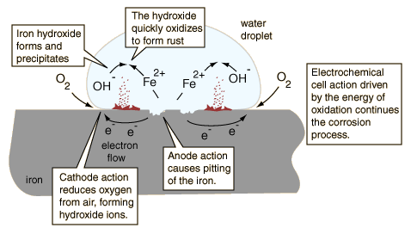

**Figure 2**: **Schematic representation of electrochemical corrosion.**

Figure 2 illustrates the four conditions which are necessary for electrochemical corrosion to occur.

These are: (i) An anodic reaction,

(ii) A cathodic reaction,

(iii) A metallic path of contact between anodic and cathodic sites (electronic conduction)

(iv) A solution which contains dissolved ions capable of conducting a current (electrolytic conduction)

From, electrochemical theory, it must be clear that no corrosion take place at the cathodic area since cathodic reaction does not involve metal dissolution. Corrosion and hence metal dissolution takes place only at the anodic area. Cathodic area stimulates corrosion of the anodic part by utilizing the electrons produced at the anodic area.

**2.2.2 Mechanism of rusting:**  Rusting is the name more commonly referred for the corrosion of iron. When iron is exposed to an atmosphere, in the presence of moisture, it undergoes corrosion. Depending upon the concentration of oxygen present in the environment different types of corrosion products are produced. Figure 3 illustrates the rusting process of iron.

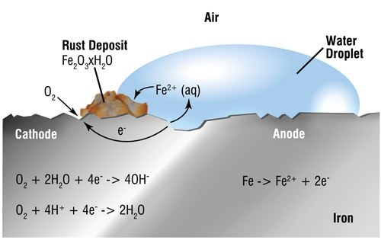

**Figure 3**: **Schematic representation of rusting of iron**

At anodic area, iron undergoes oxidation and produces Fe2+, by liberating electrons. The liberated electrons will migrate towards cathode causing corrosion current. The Fe2+ ions formed at the anode combine with OH− liberated at the cathode to form the corrosion product (ferrous hydroxide) somewhere between the anode and cathode, after diffusing towards each other through the conducting medium.

*At anodic sites*; [Fe → Fe 2+ + 2e−] x 2

*At cathodic sites;* O2 (g) + 2H2O (l) + 4e− → 4OH−(aq)

*Overall reaction*; 2Fe + O2 (g) +2H2O (l) → 2Fe2+ (aq)+ 2OH−(aq)

Reactions to the formation of hydrated ferric oxide (rust)

Fe2+(aq) + 2OH− (aq) → Fe (OH)2

In the presence of enough oxygen, ferrous hydroxide reacts with moisture and oxygen to give yellow rust.

4 Fe (OH)2 + 2 H2O + O2 → 2 [ Fe2O3. 3H2O]  **( Yellow rust)**

If the supply of oxygen is limited, the corrosion product may be black anhydrous magnetite.

6 Fe (OH)2 + O2 → 2 [ Fe3O4. 3H2O] **( Black Rust)**

Rust is a brittle substance that easily flakes off the surface to expose more iron atoms, and the process starts over again. It is too porous to shield the underlying metal from further oxidation.

**2.2.3 Differences between dry corrosion and wet corrosion**

|  |  |
| --- | --- |
| **Dry Corrosion** | **Wet Corrosion** |
| Involves direct attack of atmospheric gases | Occurs due to the existence of separate anodic and cathodic areas between which current flows through the medium |
| Do not need a corrosive medium | Needs corrosive medium |
| Types include oxidation corrosion, liquid metal corrosion and corrosion by gases | Types include galvanic, pitting, stress and intergranular |
| Less prevailing | More common |

# 3 GALVANIC SERIES

The galvanic series is an ordered listing of experimentally measured corrosion potentials of metals and alloys in natural seawater. They are arranged in the order of their corrosion tendencies/corrosion resistance.

## 3.1 Need for galvanic series

1. In the electrochemical (EMF) series a metal high in the series is more anodic and undergoes corrosion faster than the metal below it. For example, Li corrodes faster than Mg, Zn corrodes faster than Fe and so on. However, some exceptions to this generalization are known. In Zn-Al couple, Zn (below Al in the electrochemical series) is corroded; while aluminum acts as cathodic is protected. These observations, exactly opposite to that predicted by the EMF series are because metals like Al and Ti develop strongly adhering oxide layers on their surfaces. The electrochemical series does not take passivity into account.

1. The electrochemical series does not account for corrosion behavior of alloys. The electrochemical series lists Eo values of pure metals. But engineering applications involve many alloys under various circumstances. Consequently, a more practical series called galvanic series has been prepared by studying corrosion of metals and alloys in like sea water.

**3.3 Characteristics of galvanic series.**

* Galvanic series include both metals and alloys.
* Metals and alloys are arranged in the increasing order of their corrosion resistance in seawater.
* Metals and alloys having almost same corrosion characteristics are grouped within a square bracket.
* Same metal can occupy two positions in the galvanic series; For example, aluminum occurs both active and noble region depending upon its active and passive states.

Figure 4 shows the schematic representation of the EMF Series and Galvanic series

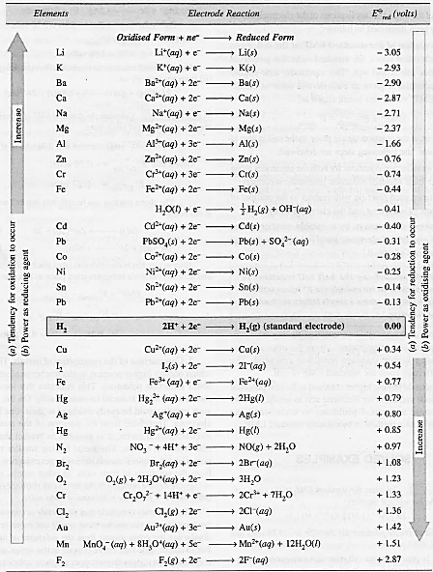 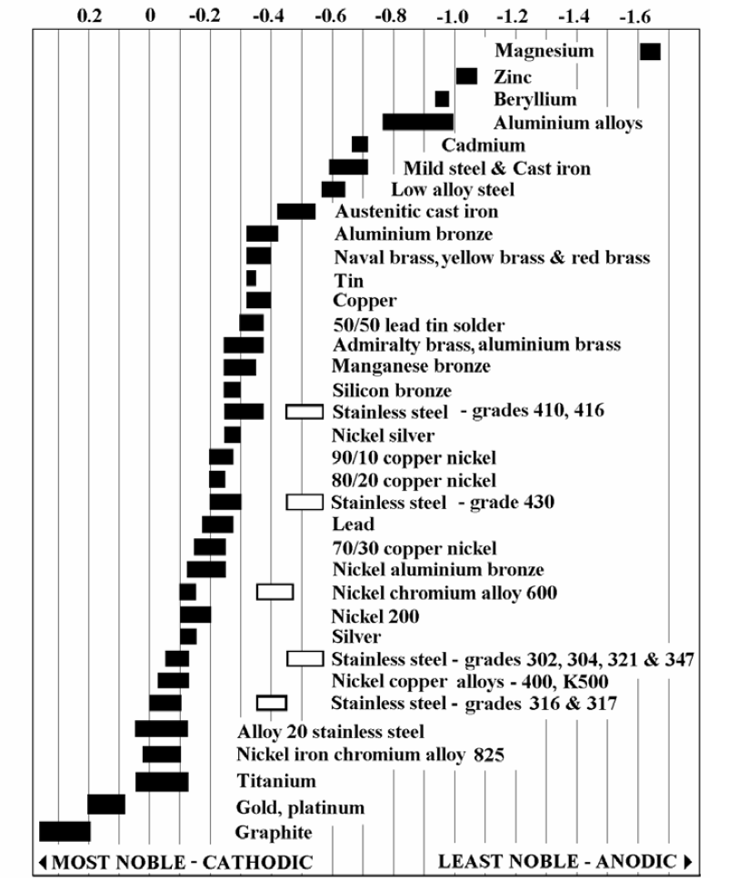

**Figure 4: The schematic representation of EMF Series and Galvanic series**

## 3.4 Comparison between electrochemical and galvanic series

* In electrochemical series, electrode potentials are measured by dipping pure metals in their salt solution of 1M concentration without any oxide film on it. The galvanic series was developed by studying corrosion of metals and alloys in unpolluted sea water, without their oxide films.
* The position of a given metal in electrochemical series is fixed based on the electrode potential value. The position of a given metal may shift in galvanic series as it takes active and passive states, irrespective of its electrode potential.
* Electrochemical series gives no information regarding the position of alloys. Alloys are included in galvanic series based on their corrosion behavior
* In electrochemical series, metals and non- metals are included. In galvanic series, only metals and alloys are included.

# 4. TYPES OF CORROSION

## 4.1 Galvanic corrosion

Galvanic corrosion occurs when two dissimilar metals are in physical contact in an aqueous electrolyte. The less resistant metal acts as the anode (metal with lower electrode potential) and the more resistant metal (metal with higher electrode potential) function as the cathode. Figure 5 depicts galvanic corrosion showing the anodic and cathodic regions and the direction of electron flow.

Some examples of galvanic corrosion include:

*copper piping connected to steel tanks.

* Zinc coated screws in a sheet of copper,

*A stainless steel screw in contact with cadmium plated steel washer.

* Steel propeller shaft in bronze bearing

The severity of galvanic corrosion depends largely on the amount of the moisture present. Corrosion is greater in the coastal region than in a dry rural atmosphere. Condensate near a seashore contains salt and therefore is more conductive (and corrosive) and a better electrolyte than condensate in an inland location. Accelerated corrosion due to galvanic effects are usually more pronounced near the junction with attack decreasing with increasing distance from that point. In the galvanic couple like Zn/Fe, Fe/Sn, Fe/Cu, Zn/Sn, Zn/Cu; the first metal is anodic with respect to the second metal and hence undergoes corrosion. It is to be noted that nuts, bolts, and hinges are made up of one single metal or alloy to prevent the galvanic corrosion.

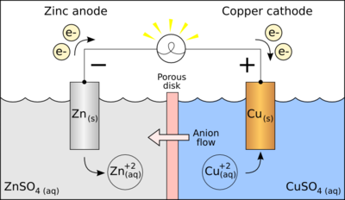 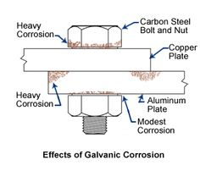

**Figure 5: (a) Galvanic Corrosion (b) Effects of Galvanic Corrosion**

## 4.2 Pitting Corrosion

Pitting corrosion is a localized attack that results in extreme cases holes in the metal. Pits are sometimes isolated or close together that they look like a rough surface. Generally, a pit may be described as a cavity or hole with the surface diameter about the same length as or less than the depth. Pitting is localized, and intense form of corrosion and failure often occurs with extreme suddenness without prior indication. The important reasons for the pitting corrosion include

* Surface roughness or non- uniform finish.

* Scratches or cut edges.
* Local straining of metal due to non- uniform stress.

*Deposition of extraneous matter such as sand, scale, water drop and dust

Whenever dust particles are deposited, owing to the different amount of oxygen in contact, with metal, the small part becomes the anodic areas, and the surrounding large parts become the cathodic area. Intense corrosion starts just underneath the impurity. Examples: peeling of tin coat on iron, deposition of dust, sand on the steel surface Pitting form of corrosion can be represented as shown in Figures 6.

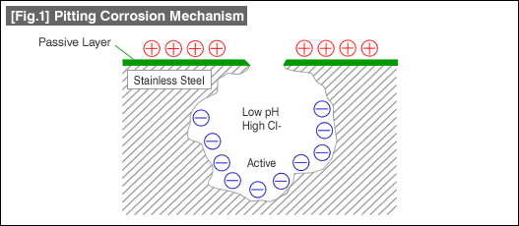 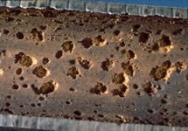

**Figure 6: (a) Pitting Corrosion (b) Effects of Pitting Corrosion.**

Autocatalytic Nature of Pitting

A corrosion pit is a unique type of anodic reaction. It is an autocatalytic process. That is, the corrosion within a pit produce conditions which are both stimulating and necessary within a pit produce conditions for the continuing activity of the pit. It is illustrated in Figure 7.

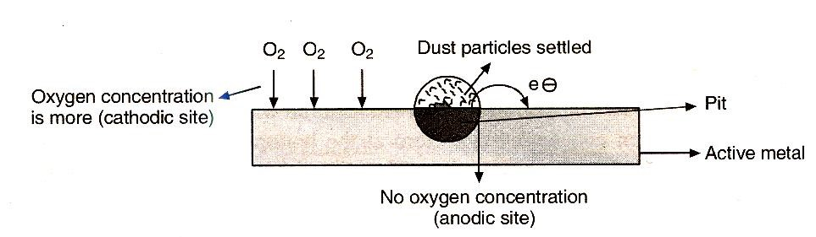 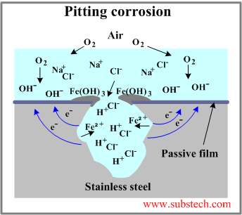

**Figure 7: (a) Autocatalytic nature of pits (b) Pitting corrosion in stainless steel**

This process is self-stimulating and self-propagating. The gravity effect is a direct result of the autocatalytic nature of pitting. Since the dense, concentrated solution within a pit is necessary for continuing its activity pits are more stable when growing in the direction of gravity.

Pitting corrosion rate increases mainly due to chloride ions present in the solution. This is probably due to an acid-forming tendency of chloride salts and higher strength of HCl. Oxidizing metal ions with chlorides are aggressive pitters. Pitting is usually associated with stagnant conditions such as a liquid in a tank or liquid trapped in a low part of an inactive pipe system. Velocity or increasing velocity often decreases pitting attack. Pitting corrosion is characterized by small anodic area and large cathodic area, resulting in accelerated corrosion at the anodic area. It causes equipment to fail because of perforation with only a small percent weight loss of the entire structure. It is often difficult to detect pits because of their small size and because the pits are usually covered with corrosion products.

## 4.3 Inter-granular Corrosion

Grain boundaries are slightly more reactive than the bulk matrix. Under certain conditions, grain interfaces are very reactive and inter-granular corrosion results. A localized attack at and adjacent to grain boundaries with relatively little corrosion of grains is inter-granular corrosion. The alloy disintegrates and or loses its strength. Impurities can cause Inter-granular corrosion at the grain boundaries, enrichment of one of the alloying elements or depletion of one of these elements in the grain boundary areas. For, eg, small amounts of iron in aluminum where the solubility of iron is low, have been shown to segregate in the grain boundaries and cause inter-granular corrosion. It has been observed that based on surface tension consideration the zinc content of brass is higher at the grain boundaries.

Depletion of chromium in the grain boundary regions results in inter-granular corrosion of stainless steels. Numerous failures of stainless steels have occurred because of intergranular corrosion. When these steels are heated in approximately the temperature range 265-419 0C, they become susceptible to intergranular corrosion. The chromium carbide in the grain boundary is not attacked. The chromium-depleted zone near the grain boundary is corroded because it does not contain sufficient corrosion resistance to resist the attack in many corrosive environments. The standard 18-8 stainless steel contains from .06 to .08 % carbon, so excess carbon is available for combining with the chromium to precipitate the carbide. This situation is shown schematically in Figure 8.

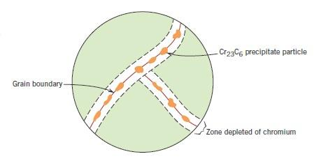 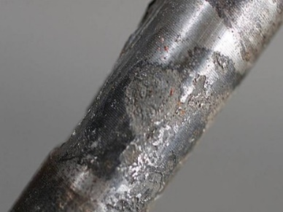

**Figure 8: Illustration for inter-granular corrosion**

Carbon diffuses towards the grain boundary quite readily at sensitizing temperatures, but chromium is much less mobile. The surface already available at the grain boundary facilitates the formation of a new surface, namely that of the chromium carbide. Chromium carbide which precipitates has been described as particles because of small size. This type of corrosion occurs along grain boundaries and only where the material, especially sensitive to the corrosive attack exists and corrosive liquid possesses a particular character of attacking only at the grain boundaries, but leaving the grain interiors untouched or only slightly attacked. This type of corrosion is because the grain boundaries contain material, which shows electrode potential, more anodic than that of the grain center in the particular corroding medium. This may be due to precipitation of specific compounds at the grain boundaries, thereby leaving the solid material solution (just adjacent to the grain boundary) impoverished (or depleted) in one constituent. The impoverished solid solution is anodic with respect to the grain centers as well as to the precipitated compound so that it will be attacked preferentially by the corrosive environment.

Eg. During the welding of stainless steel chromium carbide is precipitated at the grain boundaries, thereby just adjacent to grain boundaries becomes depleted in chromium composition and is more anodic with respect to the solid solution within the grain (which is richer in chromium). For the same reason, it is also anodic to the particles of the chromium carbide so-precipitated.

**4.4 Stress Corrosion:** Stress corrosion or cracking refers to cracking caused by the combined effect of tensile stress (residual, applied or thermal) and a specific corrosive environment. During stress corrosion/ cracking, the metal or alloy is virtually un-attacked over most of its surface, while fine cracks progress through it. The two classic cases of stress corrosion cracking are "season cracking" of brass cartridges (Figure 9) and caustic embrittlement of steel boilers.

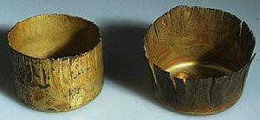

# Figure 9: Stress cracking of brass

The metal atoms under stress are at higher energy levels compared to those free from stress. The stressed part of the metal becomes more reactive than the stress-free part. Corrosion cell is formed with stressed part acting as anode and stress-free part serving as the cathode. The stressed part undergoes corrosion under specific corrosive environment, initiating the crack. It grows and propagates through the metal until the metal failure occurs or it may stop after propagating a finite distance when either the tensile stress or the corrosive environment is eliminated. Thus the stress corrosion is characterized by three distinct steps of crack initiation, crack propagation and final failure. In the first step small crack forms at some point of high-stress corrosion. Then crack propagation takes place as this crack advances incrementally with each stress cycle. The final failure occurs very rapidly once the advancing crack has reached a critical size.The caustic embitterment is a typical example of stress corrosion. This is a dangerous form of stress corrosion observed in the boiler. Water fed into boilers may contain free alkali. Water softened by lime soda process contains sodium carbonate. Under high temperature and pressure prevailing within boilers, sodium carbonate hydrolyzes to sodium hydroxide and carbon dioxide.

Na2CO3 (aq) + H2O (l) → 2NaOH + CO2(g)

Thus water inside the boiler becomes very dilute NaOH solution. Local stresses exist in metal sheets of the boiler under rivets. Minute cracks develop on the metal sheets when the stress is relieved. Dilute NaOH solution flows into these minute hairline cracks. Water evaporates by the heat of the metal, depositing sodium hydroxide within the cracks. Freshwater flows into them and evaporates again depositing more NaOH. The concentration of NaOH increases in these cracks due to the repetition of this process. NaOH concentration cell forms between the stressed and unstressed part of the metal. The sodium hydroxide attacks the metal forms sodium ferroate (Na2FeO2) which further undergoes hydrolysis according to the following equation regenerating NaOH.

Iron / Concentrated, Dilute / Iron

(stressed) NaOH (cracks) NaOH (unstressed) (boiler water)

# ANODE CATHODE

3Na2FeO2 + 4 H2O → 6NaOH + Fe3O4 + H2

6Na2FeO2 + 6 H2O + O2 →12NaOH + 2Fe2O4

When iron changes to these oxides metallic properties like malleability and ductility are lost. It becomes brittle. The brittleness is caused by caustic alkali. Hence it is called caustic embrittlement. The minute hairline cracks are caused by local stresses under the rivet heads. The continuation of caustic embrittlement of boiler parts often results in boiler failure, and extreme cases may lead to the boiler explosion. The following methods can minimize the caustic embrittlement;

1. Na2SO4, tannin or lignin is added to water. These substances deposit within the cracks and prevent the infiltration and accumulation of NaOH.
2. The boiler can be constructed by welding the sheets to avoid local stresses.
3. Caustic embrittlement is minimized by using demineralized water that does not contain NaOH and Na2CO3.

# 5 FACTORS AFFECTING CORROSION

The rate of corrosion of a material in a given environment is influenced to a varying degree by several factors. These factors can be classified into two types given below:

1. *Primary factors* – the factors associated mainly with the metal
2. *Secondary factors* – the factors which vary mostly with the environment

## 5.1 Primary factors

Factors related to the corroding metals are known as primary factors.

*(a) Nature of metal and relative electrode potentials of metals*

In general, the metals with lower electrode potential are more reactive than the metals with higher electrode potential.. The magnitude of corrosion cell potential is one of the major factors which decide the corrosion rate. The larger the potential difference between the anode and cathode of the corrosion cell, higher is the corrosion rate. When two different metals with a large difference in their electrode potential are in contact with each other, the more reactive metals undergo corrosion. When the potential difference is more, higher corrosion current is produced. Example; Corrosion of zinc is faster than iron when in contact with copper in a medium. This is because the electrode potential difference between Zn and Cu is greater than that of Fe and Cu.

.*(b) Relative Cathodic and Anodic area*

The rate of corrosion is greatly influenced by the relative areas of the anode and cathode. If a metal has a small anodic area and large cathodic area, then the corrosion is more intense and faster. This is shown schematically in Figure 10(a)

At anode oxidation takes place, and electrons are liberated. At the cathode, these electrons are consumed. When the anode is smaller, and the cathode region is large all the electrons liberated at the anode are rapidly consumed at the cathode region. The smaller anodic areas can meet the demand for electrons by the large cathodic areas by undergoing corrosion at a faster rate. This makes the anodic reactions to take place at its maximum rate thus increasing the corrosion rate. Example; Small steel pipe fitted in a large copper tank, iron bolt and nuts in copper boilers.

If the cathode is smaller, the consumption of electrons will be slower, and the corrosion reaction as a whole will be slower as shown schematically in Figure 10(b).

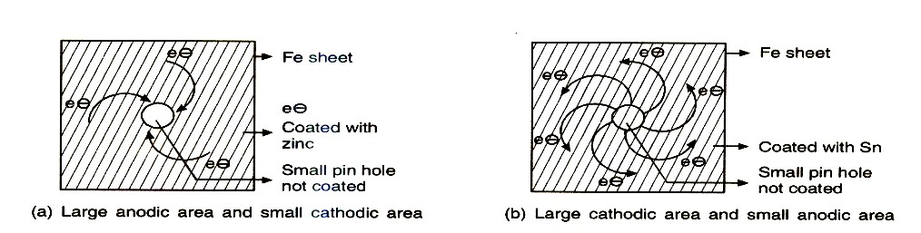

**Figure 10. Schematic representation of the effect of the ratio of the anodic and cathodic area**

*(c)Hydrogen Overvoltage*

The difference between the observed potential at which reduction of H+ ions to H2 gas occurs at a cathode and the theoretical potential at which it should have occurred is known as hydrogen overvoltage. The magnitude of hydrogen overvoltage depends upon the nature of the metal used as the cathode. Increased hydrogen overvoltage at a cathode reduces the corrosion rate when the reduction of H+ ions is the cathodic process. When the hydrogen evolution reaction on the metal surface is low, H2 gas is liberated easily, and then the cathodic reaction rate is faster. This makes the anodic response also faster, thereby promoting overall corrosion reaction.

*(d) Nature of corrosion product*

The corrosion product is usually an oxide of the metal which may or may not form a protective layer on the metallic surface. If the corrosion product deposits and is insoluble, stable, uniform adherent and nonporous, it acts as a protective film preventing the further corrosion of metal. E.g., formation oxide film on the surface of aluminum, chromium, and titanium.

If the corrosion product is not deposited and is soluble, unstable, non- uniform, non-adherent and porous, the corrosion continues unabated since in such cases fresh metal surface is continuously exposed to the corrosion environment, and corrosion of the metal surface takes place continuously. E.g., Corrosion of iron and zinc.

If the corrosion product is soluble in the corrosion medium or evaporates, then corrosion proceeds at a faster rate as a fresh metal surface is exposed continuously to the corrosive environment, and the destruction of the surface occurs continuously. E.g., Molybdenum oxide

If the corrosion product interacts with the medium to form another insoluble product, then protective film formed on the metal prevents further corrosion.e.g.PbSO4 formed in the case of Pb in H2SO4.

**5.2 Secondary factors**

Factors related to the environment are known as secondary factors

1. *Concentration and nature of electrolytes*

Rapid corrosion takes place at a high ionic concentration of the electrolyte. The conductivity of deionized water is 1-10 millimhos per meter. Conductivities of tap water and seawater are 10-20 milli-mhos per meter and 5.3 mhos per meter respectively. Therefore, the corrosion rate in seawater is nearly 500 times as fast as that in tap water and 5000 times as fast as that in demineralized water. In the marine atmosphere, the presence of sodium and other chlorides leads to increased conductivity of the liquid layer in contact with the metal surface. So the corrosion rate is increased. Salt air of coastal cities is very damaging to exposed metal when compared to that at interior places. In the vicinity of industrial areas, the atmosphere contains corrosive gases like CO2, SO2, H2S, and fumes of HCl, H2SO4.So the acidity of the liquid adjacent to the metal surfaces increases and its electrical conductivity also increases. This increases the corrosion current in the electrochemical cells on the metal surface.

Some electrolyte cause polarization and bring down the corrosion rate. The phosphate ions form an insoluble, protective phosphate film of metal ions on the surface of a metal and reduce its corrosion rate. The chloride ions penetrate the protective oxide film of metal increasing the ionic conductance of the film. Protective action of this film decreases as a result of this and corrosion rate gets enhanced.

1. *pH of the medium*

In general, lower the pH of the corrosion medium, higher is the corrosion rate. The acidic media provides a more conducive environment than the alkaline or neutral media. The corrosion rate increases slowly and gradually with decreasing pH and become rapid at pH less than 4. At pH > 10, corrosion of iron practically ceases due to the formation of a protective coating of hydrated oxides of iron. However, some metals like Al, Zn, and Pb, undergo fast corrosion in highly alkaline solution.

*(c) Temperature*

The rate of a chemical reaction in general increases with the rise in temperature. Curve A of Figure 11 indicates the corrosion of Nickel in HCl. Increase in temperature increases the conductance of the corrosion medium, which also contributes to the increase in corrosion rate. In the case of corrosion resistant passive metals, the rise in temperature decreases the passive range and thereby increases the corrosion rate. However, in some cases, initial negligible temperature effect will be followed by a very rapid in the corrosion rate at a very high temperature. This trend is reflected in Curve B of Figure 11. An example is the corrosion of stainless steel in HNO3. This is because increasing the temperature of nitric acid gently increases its oxidizing power. At low or moderate temperature, stainless steels exposed to the nitric acid are in the passive state very close to the trans-passive region. Hence at elevated temperature, there will be an increase in the oxidizing power of the medium which increases the rate of corrosion. However, if the corrosion medium contains dissolved gases, the solubility of the gases decreases with temperature. In such a situation corrosion rate also decreases. Presence of too much humidity also reduces the rate of corrosion

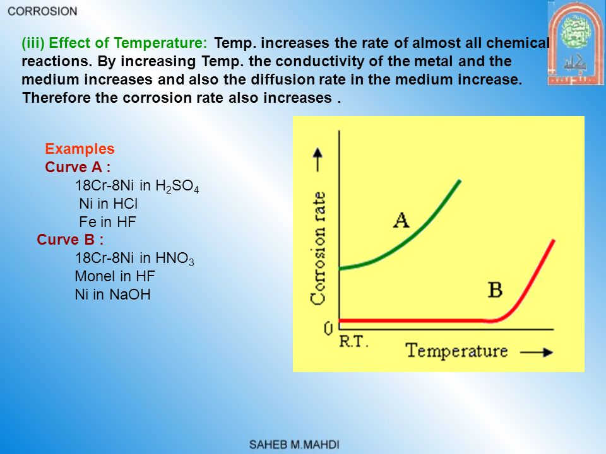

**Figure 11**. Effect of temperature on the corrosion rate of Ni in HCl and stainless steel in HNO3

***(d)*** *Polarization at the anodic and cathodic region*

During electrochemical corrosion both anode and cathode can no longer be at their reversible equilibrium potentials. The deviation from reversible equilibrium potential of an electrode when brought in contact with another electrode is called polarization. There is a variation of electrode potential due to an inadequate supply of species from the bulk of the solution to the electrode. In the process of corrosion, the polarization of an anode or cathode decreases the corrosion rate substantially as anode and cathode polarization retards anode and cathode reactions respectively. Because of anodic polarization (i.e., shifting of potential to more positive values and the current to lower value), the tendency of the anodic metal surface to undergo oxidation decreases. It slows down the anodic reaction and thus decreases the overall corrosion rate. Cathodic polarization retards the cathodic reaction. This can be due to the chemical polarization of the cathode reactant with an electron. The retarded movement of the cathodic reactant to the cathode surface or retarded removal of the cathodic reaction product from the surface of the cathode also makes the cathodic reaction slower. For the corrosion to continue both anodic and cathodic reaction should take place simultaneously. The slow rate of any one of the reactions makes the corrosion reaction slower.

# 6. PROTECTION AGAINST CORROSION

Corrosion of metals occurs when they come in electrical contact with a corrosive environment. Therefore metallic corrosion can be prevented by either changing the metal or altering the environment or by separating the metal from the environment. Also, corrosion can also be prevented by changing electrode potential of the metal. The most effective and economical method; however, is to deal with the corrosion problem at the design stage itself.

Various methods available for corrosion control are listed below;

*Selection of material & design improvement

*Change of metal

*Change of environment

*Use of coatings for separating metal from the environment

## 6.1 Selection of materials and proper design

*Selection of materials:-* Planning for corrosion prevention starts with the selection of appropriate metals and alloys. Therefore one has to take into account the following material selection principles.

1. Noble metals such as Pt, Au, and Pd do not undergo corrosion. But one cannot use noble metals because of its prohibitive price. Pure metals show greater resistance to corrosion than an impure one.
2. The rate of corrosion can be controlled by using an anodic material of larger area and cathodic material of smaller area.
3. Suitable alloying of metals in some cases improve its corrosion resistivity.
4. Avoid residual stress in fabricated articles by proper heat treatment (annealing)
5. The use of two dissimilar metals having the large difference in their electrode potentials should be avoided. Under unavoidable circumstances, the metals chosen should be very close in the galvanic series. Proper insulator fitting may be used in between to prevent direct contact of metals.

*Proper design: -* A good design minimizes corrosion in metallic structures or equipment. A large number of corrosion failures are due to improper design and inability to use available knowledge.

Proper designing of the equipment can control corrosion possibilities. Some of the more important general rules for design which should be observed are described below:

**a)** **Simplify forms**: structures having simpler forms can be protected easily and efficiently. A complicated shape having more angles, corners, edges and internal surfaces will have a larger surface area exposed to the corrosive environment and will be difficult to protect by painting or other surface treatment Improvement in design can be achieved through welding the joints as shown in Figure 12.

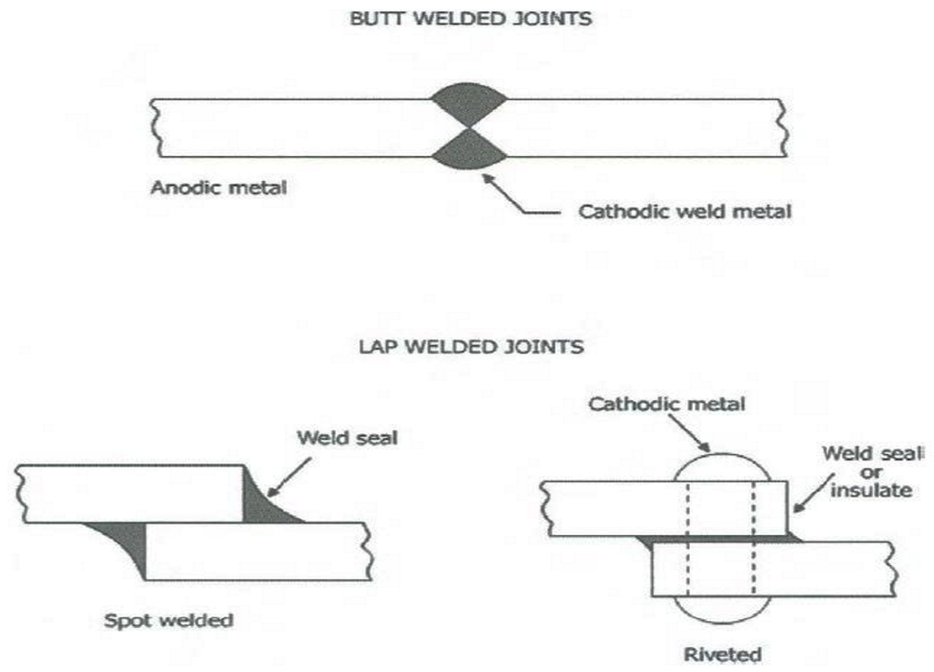

# Figure 12: Improvement of design by welding the joints

Electrical boxes exposed to the atmosphere should be so designed that water does not collect at the top or in the crevices. The profile should be so designed that water is drained completely and moisture retention should be as low as possible.

**b) Avoid crevices**: Crevices allow moisture and dirt to be trapped which result in increased corrosion. If crevices are either present in a structural or cannot be avoided they should be filled by welding or by using filler. (Figure 13)

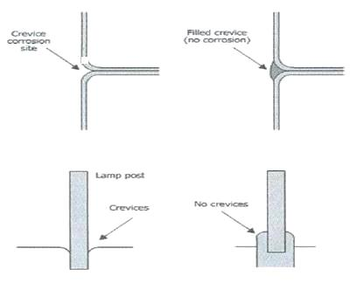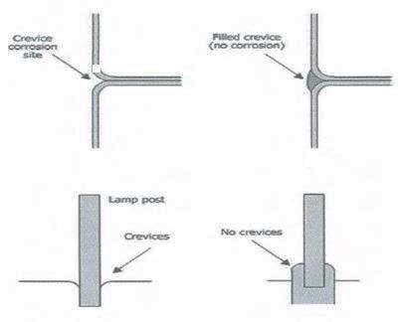

# Figure 13: Improved designs to minimize crevice corrosion

c) **Avoid residual moisture**: The design should be such as to protect the structure from retained or residual moisture. To avoid residual moisture, ventilation is usually as important as drainage. Free circulation of air should reduce condensation. (Figure 14)

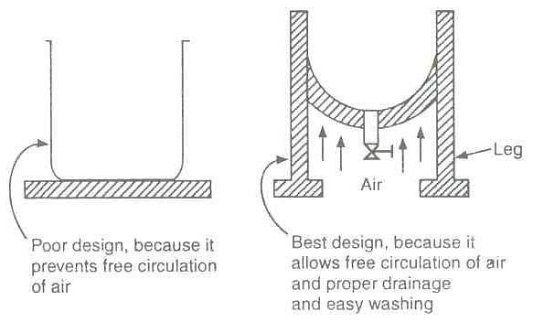

# Figure 14: Improved design to minimize differential aeration corrosion

d) **Avoid sharp corners and bends:** These are the potential corrosion sites, and round corners must replace these. Sharp corners result in the thin coating at corners and are not protected effectively rounding the corners resulting in an even coating. Sharp bends and other areas were the fluid directions changed rapidly can promote corrosion and should, therefore, be avoided. (Figure 15)

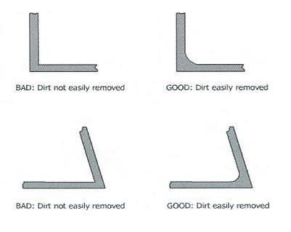

**Figure 15: Improved design with minimum sharp corners**

## 6.2 Cathodic protection

Corrosion of a structure can be controlled if the entire article can be changed into the cathodic part of a corrosion cell. This is called cathodic protection. Ship's steel hulls, offshore drilling platforms, oil and gas undersea pipelines, containers used to store water and other liquids are protected by this method.

Two different methods do cathodic protection.

a) Sacrificial anode method b) Impressed current method

# a) Sacrificial anode method

A more reactive metal is kept in contact with the metal structure to be protected by this method as shown in Figure 16. The reactive metal becomes the anodic part, and the structure becomes cathodic part of the corrosion cell. The anode is sacrificed to protect the structure. Hence this method is called a sacrificial anode method.

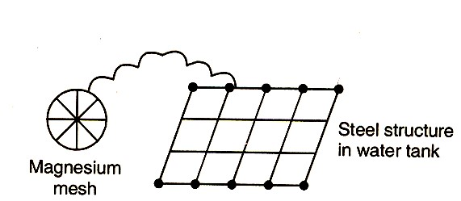

**Figure 16**: **Mg is used as the sacrificial anode for protecting the iron article**

Mg is more reactive metals than iron, and hence it is usually used as the anode. It becomes anodic part in contact with iron. Following reaction takes place when Mg is made to couple with Iron.

Anode: 2Mg(s) → 2Mg2+ (aq) + 4e− Cathode: O2 (g) + 2H2O (l) + 4e−  → 4OH−(aq)

Net reaction: 2Mg (s) + O2 (g) + 2H2O (l) → 2Mg(OH)2 *Advantages:* * No external power supply is necessary.

* Can be used in remote and difficult to reach areas.
* Low installation cost.
* Minimum maintenance cost.
* Replacement is much cheaper than replacing the tank/oil pipeline

**b) Impressed Current Method.**

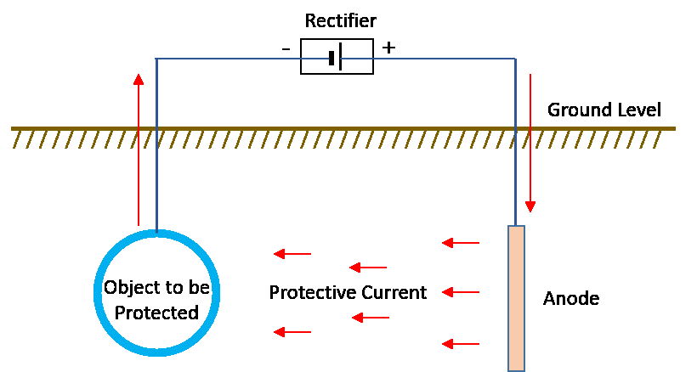

**Figure 17: Schematic diagram of an impressed current method**

In this method, the metallic structure is made cathode with the use of impressed current by connecting the negative terminal of the external DC power source to the metallic structure to be protected and positive to an inert anode. The anode may be made up of steel, graphite and platinum group metals. The anode may be consumed very slowly or may not be consumed at all depending on the anode material. The anode is surrounded by backfill consisting of coke breeze, gypsum to improve electrical contact between the anode and the environment if it is a weak ionic conductor. Schematic representation of an impressed method to control corrosion is shown in Figure 17.

*Advantages*:

* Applicable to large structures and long-term operations.
* Uncoated parts can be protected.

*Disadvantages:*

* Larger installation cost.
* Higher maintenance cost.
* High energy consumption
* Localized corrosion may occur if the impressed current is not uniform on the entire surface.

## 6.3 Anodic protection method

Anodic protection is based on the fact that under specific ranges of potentials a metal or alloy becomes passive, resulting in the lowering or prevention of corrosion. Anodic protection may be understood using the potential current density diagram as shown in Figure 18.

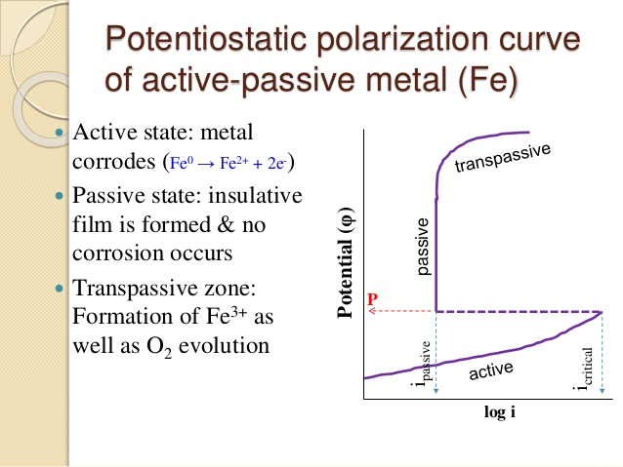

**Figure 18**: **Plot of Potential Vs. Corrosion current (corrosion rate).**

Certain metals and alloys lose chemical reactivity under certain environmental conditions. This is a phenomenon of complex nature, and it occurs under specific conditions. This phenomenon is called passivity of metals. E.g., Al, Ti, Cr, Ni, Mo, and alloys containing a significant amount of these metals. The curve is obtained by applying a known potential to a metal specimen and measuring the current changes. As the potential is increased, initially current also increases (AB) indicating the dissolution of the metal. This trend continues until the current reaches a critical value (Icrit) and passivation due to the development of an oxide layer sets in. This potential is called passivating potential (Ep).

Above Ep the current flow decreases and reaches a minimum value called the passivating current, I passive. The decrease in current is due to the formation of a passive film on the metal. If the potential is further increased the metal remains unattacked up to a particular potential is reached (CD).In this range, the corrosion rate of the metal is minimal.

The potential range in which the anodic protection can be achieved is called the passive region. The optimum potential for anodic protection is midway in the passive region since it permits slight variations in the controlled potential without affecting the corrosion rate. Beyond the point D any further increase in potential tends to increase the current due to the dissolution of metal. It is called trans-passive region.

The mechanism of protection thus lies in the act of applying specific potential range in which no corrosion takes place. This potential range depends primarily on the relationship between the metal and reactants resulting in passivity. This technique protects Iron, Nickel, Chromium, Titanium and their alloys. The anodic protection of a structure is applied by using a device called potentiostat. It is an electronic device that maintains a constant potential with respect to a reference. The anodic protection of steel tank containing sulphuric acid is shown in Figure 19.

Potentiostat has three terminals. One connected to the storage tank, other to an auxiliary cathode (Pt) and third to a reference electrode (Calomel).In operation the potentiostat maintains a constant potential between the tank and the reference electrode, corresponding to the passive range.

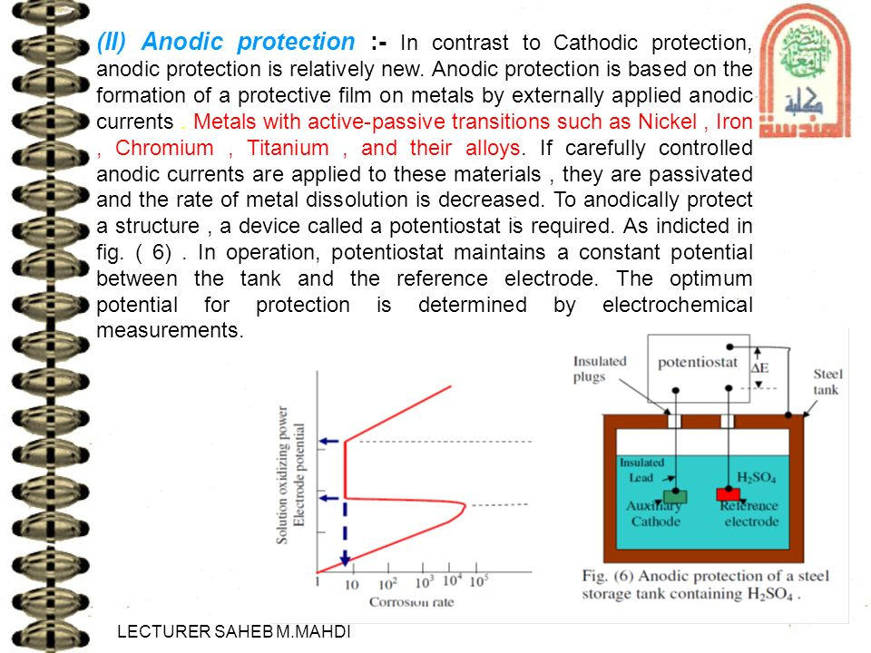

**Figure 19: Potentiostat used in anodic protection**

The potential is initially increased to Ep for the corrosion to occur, then increased to Ef (fade potential) when the current decreases to a small value. Now the potential is kept at constant Ep, and the current is maintained at Ip. Example: Stainless steel containers used for transporting corrosive chemicals are protected from corrosion by supporting them at proper Ef and Ip.

*Advantages:*

* Reduced equipment cost-i.e. it is possible to protect two or more vessels with one controller Cost of anodic protection is generally independent of tank capacity.
* Applicable in extremely corrosive environments
* Low current demand

*Disadvantages:*

* Cannot be applied in case of corrosive medium containing aggressive anions such as chloride.
* Needs a continuous supply of electric current
* Applicable only to those metals that show active, passive behavior
* Initial installation cost is high
* It cannot reduce the corrosion rate to zero.

## 6.4 Use of corrosion inhibitors

The use of corrosion inhibitors is a possible means of corrosion control by altering the environment. A corrosion inhibitor is any chemical substance which when added to a solution (usually in small amounts) increases the corrosion resistance. Corrosion inhibitors are used in various industrial applications, including cooling water systems, automobile engine coolants, acid pickling solutions, in the surface treatment of metals, in paints and organic coatings. The mechanisms of corrosion inhibition are different for acidic and neutral solutions. In acid solutions, natural oxide films initially present on the metal surface are dissolved away so that inhibitors then interact directly with the metal surface. In neutral solutions, the system is more complicated because the metal surface is oxide covered and also because dissolved oxygen may participate in the electrode reaction. Many inhibitors protect against corrosion either by retarding anodic dissolution process or cathodic reduction process or both the processes. By this property, inhibitors can also be classified either as anodic or cathodic inhibitors.

1. **Anodic Inhibitors:** Substances used to stop the anodic reaction are called anodic inhibitors. They form insoluble compounds with the metal ions formed at the anodic part due to its initial corrosion. These insoluble compounds form a protective film on the anode surface. This film isolates the anode from the electrolyte medium and stops its corrosion. The anions such as chromate, tungstate, molybdate, and phosphate are used to arrest anodic processes. Anodic inhibitors are found to be effective provided they are added above their critical concentrations. If the added inhibitor is insufficient, it cannot plug all the anodic sites. This leads to severe pitting corrosion.
2. **Cathodic Inhibitors:**  Substances used to stop cathodic reaction are called cathodic inhibitors. They form a protective film on the cathodic surface and isolate it from the electrolyte medium. Cathodic reaction stops as a result of this.

There are two major reactions taking place on the cathodic surface depending on the nature of the corrosive environment. They are: 1) Hydrogen evolution type 2) Oxygen absorption type

1) *Hydrogen evolution type inhibitors:-* 2H+ (aq)+ 2e- -------->H2(g) (acid medium)

The evolution of hydrogen gas over the cathode can be prevented either by retarding the diffusion of H+ ions to the cathode or by increasing the hydrogen overvoltage. The diffusion of H+ to the cathode is retarded by the addition of certain organic compounds which contain N or S. Urea, thiourea, mercaptans and heterocyclic nitrogen compounds are widely used as cathodic inhibitors. Such substances are adsorbed on the cathodic sites forming a protective film that suppresses cathodic reaction. Even the use of insufficient concentration of these substances does not have any adverse effect.

Increasing overvoltage of hydrogen can also prevent the evolution of H2 at the cathode. This is achieved by the addition of oxides of Arsenic, Antimony or salts like sodium meta-arsenite. They deposit as an adherent metallic film on the cathode areas thereby prevents the evolution of H2 since hydrogen overvoltage for those metals is quite high.

2) *Oxygen absorption type inhibitors:-* O2(g) + 2H2O (l) + 4e− → 4OH−(aq) (in neutral or slightly alkaline medium)

This cathodic reaction can be easily controlled either by removing the oxygen from the corrosive media or by decreasing the diffusion rate of oxygen to the cathode. Reducing agents such as N2H4 and Na2SO3 remove oxygen from the corroding environment by combining with it.

N2H4 + O2 → N2 + 2H2O

Decreasing the diffusion rate of oxygen is achieved by adding salts such as ZnSO4, MgSO4, NiSO4 to the aqueous environment. They undergo hydrolysis and form a deposit of their insoluble hydroxide on the cathodic sites.

Zn2+ (aq) + 2OH− (aq) → Zn(OH)2.

The protective film being impermeable to oxygen prevents its further diffusion to cathodic sites.

## 6.5 Surface Coating

A protective coating on the metals and alloys isolates them from electrolyte medium, and hence corrosion cells do not work. This prevents corrosion.

Metallic Coating: Coating of a metal on a substrate metal requiring protection against corrosion is metallic coating. There are two types of metallic coating. They are

* *Anodic metal coating* – coating the substrate metal with a more anodic metal, eg. galvanizing
* *Cathodic metal coating* - coating the substrate metal with a more cathodic metal, eg. tinning **Galvanization:** Giving a Zn metal coating on iron and mild steel is known as galvanization.

When the coating covers the entire surface of the substrate metal, the coating isolates it from the environment and protects it against corrosion. When the coating breaks or cracks zinc act as the anode, and the substrate iron and mild steel acts as the cathode. Thus zinc becomes the sacrificial anode and provides protection to iron, and mild steel sheets, pipes, wires are usually galvanized.

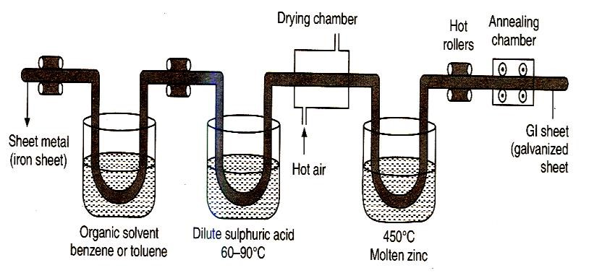

**Figure 17**. Galvanization process

***Pretreatment*:** The metal surface is cleaned to remove organic matter like grease/oil by washing with organic solvents. The rust and other deposits are removed by washing with dilute sulfuric acid, and the surface is finally washed with water and air dried.

***Process****:* Galvanization is done by hot dipping processes. The melting point of Zn is 419o C. Zn is melted and kept at 425-430o C. Ammonium chloride flux is spread over it to prevent its oxidation by air. Iron and mild steel objects are degreased, pickled and cleaned. They are then dipped in molten Zn bath. Pair of hot rollers wipes out the excess of zinc coating to produce a thin uniform coating on the objects which are then cooled. It is shown schematically in Figure 17. Galvanized sheets cannot be used to prepare tins or cans for storing food materials, because zinc salts are toxic.

*Applications*: Used in the manufacture of fencing wire, roofing sheets, buckets, bolts, nuts, nails, and screws.

**Tinning:** A process involving a coating of tin on iron and mild steel is called tinning. Tinning protects the article until the coating covers the surface thoroughly, by isolating it from the environment. When the coating cracks or breaks severe or pitting corrosion of the articles at the exposed region occurs, because tin is cathodic with iron and small anodic areas are in contact with the large cathodic area.

***Pretreatment***: Steel sheet is washed with organic solvents to remove grease/oil deposits. It is then treated with dilute sulfuric acid to remove rust deposits and finally washed with water and air dried.

***Process:***Tinning is done by hot dipping. The melting point of Sn is 232o C. Tin is melted and kept at 250o C. It is covered with ZnCl2 and NH4Cl flux to protect liquid tin from oxidation by air. It is dipped in the molten tin, and the passed through rollers kept in palm oil to squeeze out excess tin from it. The sheet is cooled, rolled and stored. It is shown in Figure 20.

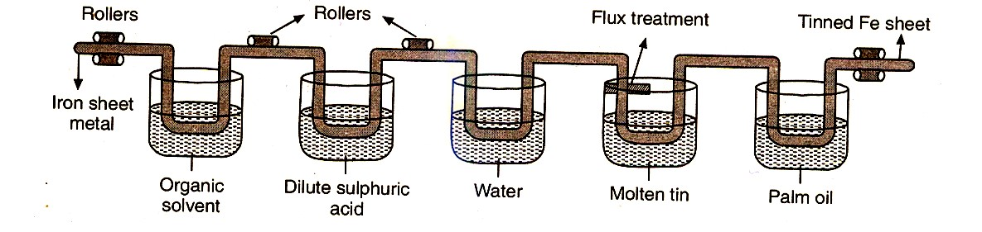

**Figure 20: Tinning Process**

*Applications:*

Used for coating steel, copper, and brass,

Used in the manufacture of containers for storing foodstuffs

For making cooking utensils and refrigeration equipment.

***Comparison of Galvanizing and tinning***

|  |  |
| --- | --- |
| **Galvanizing** | **Tinning** |
| A process of coating Zn over iron/ steel to prevent it from rusting (anode metal coating) | A process of coating Sn over iron to prevent it from corrosion (cathode metal coating) |
| Hot rollers used to wipe excess coat are not immersed in oil | Hot rollers are immersed in oil |
| Galvanized containers cannot be used to store acidic foodstuffs because zinc reacts with food acids forming highly toxic zinc compounds. | Tin coated containers can be used to store foodstuffs because tin is nontoxic and does not react to cause any food poisoning |
| Zinc protects the underlying iron by sacrificial action | Tin protects the base metal iron due to its noble nature. |
| Zinc continues to protect iron by sacrificial action in the event of puncture/break in coating | Tin protects the iron until the coating is perfect and any break causes rapid corrosion of iron |

**6.6 Organic Coating:**

Organic coatings are inert barriers like paints, varnishes, lacquers, and enamels applied on a metallic surface for both corrosion protection and decoration. These involve a relatively thin barrier between the substrate material and the environment. As a rule, these coatings should not be used where the environment would rapidly attack the substrate material. The protective value of such a coating depends on (i) its chemical inertness to the corrosive environment, (ii) its good surface adhesion, (iii) its impermeability to water, salts and gases and its proper application method.

**6.7 Inorganic coating:** They are also known as chemical conversion coatings. These are inorganic

barrier produced by chemical or electrochemical reactions, brought at the surface of the base metal. Phosphate coating is produced by the chemical reaction of base metal with an aqueous solution of phosphoric acid and phosphates of iron, zinc, manganese along with copper salts as accelerators. Such coatings are usually applied to iron, steel, and zinc by either immersion or spraying or brushing. The chemical reaction between the phosphating solution and the base metal results in the formation of a surface film, consisting of crystalline zinc-iron or manganese- iron phosphates.

# 7. SUMMARY

Corrosion is one of the problems often encountered in industrialized society, and its study is important from the point of an engineering. Enormous breadths of engineering systems depend upon corrosion protection for their reliability, performance, and safety. These corrosion problems are typically complex phenomena, affected by many variables and not necessarily restricted to one form of corrosion. The different types of corrosion include galvanic, pitting, inter-granular and stress corrosion. Certain factors can tend to accelerate the action of a corrosion cell, and these include nature of the metal and their relative environment, cathode and anode areas, nature of corrosion products, hydrogen overvoltage pH of the medium, temperature, and polarization Various measures are taken in almost all industries to control the corrosion rate. Corrosion control techniques include the selection of materials and proper design, cathodic and anodic protection methods, surface coating and the use of corrosion inhibitors.

**8. Review questions**

1. Explain the meaning, importance, and consequences of corrosion in the industry and our day-to-day lives.
2. Describe mechanism of rusting of iron.
3. Comment on the following statements, which can be either true or false.
   1. Al2O3 is corrosion resistant, but Fe2O3 promotes corrosion
   2. A scratch formed on iron sheets coated with tin results in severe corrosion but the case is the reverse when it is coated with zinc.
4. Explain the following terms as they apply to the corrosion; (a) Cathodic protection (b) anodic protection.
5. Distinguish between dry and wet corrosion.
6. Explain the electrochemical theory of corrosion.
7. What are corrosion inhibitors? Explain the types of inhibitors used to control corrosion with examples.
8. Distinguish between the following; i) Electrochemical series and galvanic series ii) Galvanizing and tinning.
9. Discuss the different factors affecting the corrosion process.
10. List the various methods used to control corrosion.

********